COMPASS ROSE CABIN
27907 K Place
Ocean Park, WA

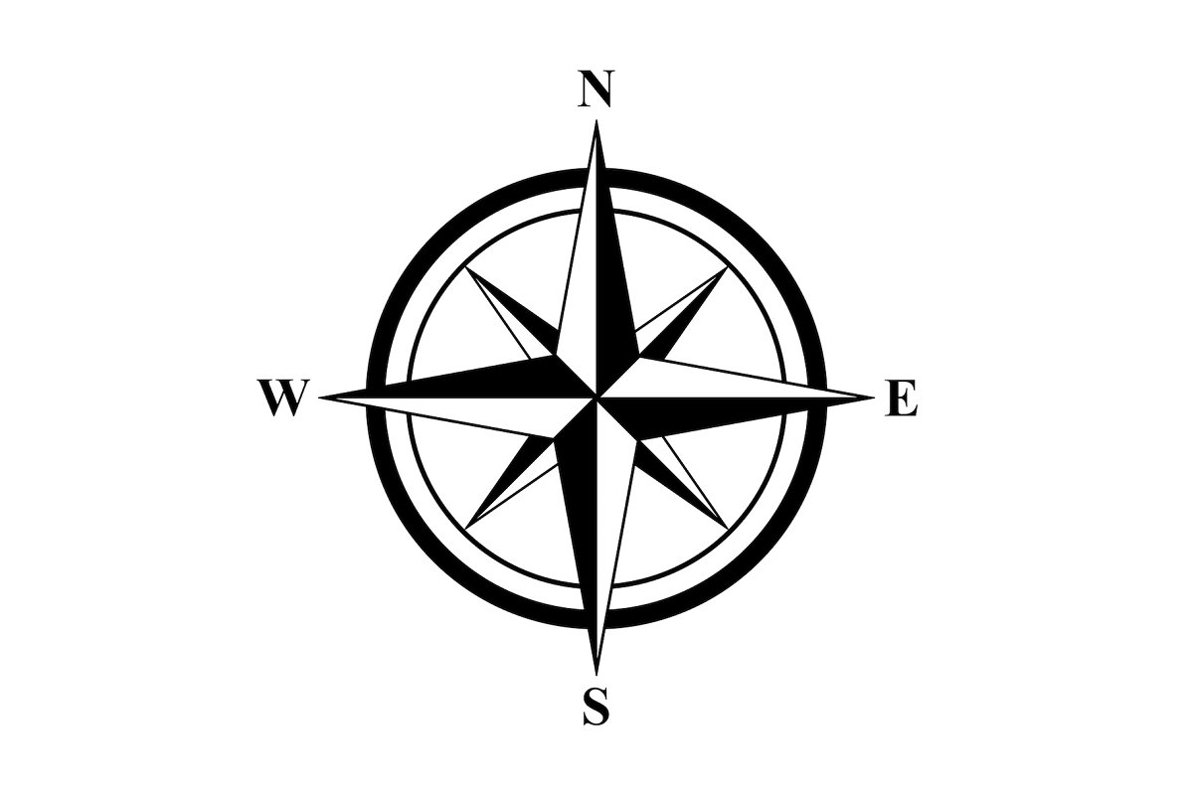

Hosted by
The Butcher Family

Welcome to the Compass Rose Cabin

Check In: 4:00 PM
Check Out: 11:00 AM

WiFi Login: Compass_Rose_WiFi
WiFi Password: Compass_Rose280

Welcome to the Compass Rose Cabin! We are so excited that you have decided to book with us and we hope that you enjoy your stay!

Compass Rose Cabin is our family beach house that we purchased during the summer of 2023. We love the peaceful retreat that it offers us here in Ocean Park. We look forward to spending time here as a family and making memories.

Compass Rose Cabin is the perfect home base for your time hear in Ocean Park. You are just a short walk away from the beach along a quiet trail through the dunes. The beach offer many activities for all ages including sand castle building, beach combing, surf fishing, razor clamming (when in season), and beautiful sunsets.

The neighborhood is a quiet community, with both part-time and full-time residents. Our neighbors are our friends, please be respectful of them and their property. Please park off the street in our driveway, as this keeps the street open for larger vehicles such a 5th wheel trailers, RVs and boats.

THE SPACE
- Compass Rose Cabin is a cozy 1 bedroom, 1 bath cabin with family area, kitchen and dining areas.
- Large windows adorn the west side of Compass Rose in the direction of the beach. Enjoy sitting on the deck and listening to the ocean while you enjoy your morning coffee or watch the sunsets in the evening. If you look hard enough you many even catch a glimpse of the ocean through the trees.

THINGS TO CONSIDER
- Compass Rose is on a septic system. Please DO NOT flush anything besides toilet paper down the toilet.
- Please be mindful to sand in the sinks and tub. Please rinse sandy feet and other items off outside prior to coming in the house.
- Compass Rose is on a private well. The well is tested annually to make sure that it meets or exceeds current drinking water standards. Well water may taste different than what you are used to at home, but it is still safe to drink.
- The gas fireplace is connected to the thermostat. It will come on when you turn up the heat. Please remember to turn down the heat when you are out and about. When you are finished with you stay, please set the heat at 65 degrees before leaving.
- Please remove your shoes when in the cabin.

KITCHEN
- For coffee we have provided both a Kuerig and a coffee pot to suit your needs. Filters for the coffee pot are located in the drawers to the left of the sink. Please help yourself to the complementary K-cups, hot cocoa and tea.
- There is an additional kitchen light switch behind the Kuerig.
- There is an electric hot water kettle for heating water.
- Pots, pans, and cooking sheets are located to the left of the stove and cooking utensils are in the drawer.
- Bowls and strainer are located in the bottom drawer to the right of the dishwasher.
- Cooking spray, salt, and pepper are located to the right of the stove.
- Zipper bags, foil, and plastic wrap are located to the right of the dishwasher.
- An extra roll of paper towels can be found beneath the sink.
- Dishwasher tablets are located beneath the sink.
- You may find a selection of basic condiments in the refrigerator. Feel free to use them.
- Extra trash bags are located under the kitchen sink.

SLEEPING ARRANGEMENTS
- Compass Rose Cabin offers a queen size bed in the single bedroom. The bedroom has large open windows that overlook the family area with window treatments that can be closed for privacy. Three steps are required to access the bedroom.
- A full-size, pull-out couch is located in the family area that can be used as a second sleeping location. Blankets and pillows for the pull-out couch are located in the drawers under the bed closest to the laundry room.
- Extra blankets and pillows are located in the drawers under the bed.

BATHROOM
- We have provided shampoo, conditioner, and body wash in pump bottles located in the shower.
- Q-tips and make-up pads are provided.
- Hair dryer is located in the bathroom vanity.
- One set of towels (bath towel, hand towel, and wash cloth) is provided for each guest. Extra towels are located in the bathroom vanity.
- Old towels for dirty feet (and paws) are located in the laundry room.

PETS
- Well-behaved, house trained furry companions are always welcome at Compass Rose
- Please do not leave pets unattended in the cabin, as many pets are not comfortable being left alone in a new place.
- Please keep pets off of the bed(s), couch, and other furniture.
- A folding crate is located in the laundry room for your use.
- Pet waste bags are located in the hall closet. Please clean-up after your pet and place all pet waste in the outside trash can.
- Old towels for dirty paws and feet are located in the laundry room.

CHECK-OUT PROCEDURES
- Check-out time is 11 am. Our cleaner will arrive shortly after check out get the cabin ready for the next guest. Your key code will deactivate at check-out time.
- Please put all used dishes in the dishwasher and start it before leaving.
- Bedding is to be left on the beds.
- Please put used towels on the floor in the laundry room.
- Please put all trash in the garbage cans outside. Please do not pile trash next to the garbage cans. All garbage must be in the cans with the lids tightly secured.
- Please set the heat at 60 degrees prior to leaving.

Please don’t hesitate to contact us through the Airbnb platform if you have any questions or concerns.
We would be happy to assist you!

We hope that you love Compass Rose Cabin as much as we do and would love to hear about your stay!
Please leave us a note in our guestbook!

